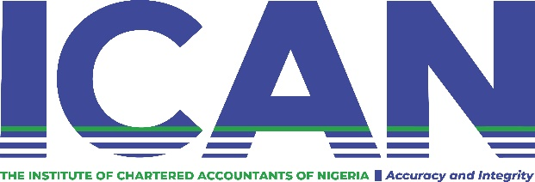
LAGOS AND DISTRICT SOCIETY
Fifth Floor, 106/110, Lewis Street, Obalende, Lagos. Tel: 0814-040-0000. email: icanlagosanddistrict@yahoo.com

MEMBERSHIP FORM

SURNAME:_________________________________________MR/MRS/CHIEF
OTHER NAMES:______________________________________________________
____________________________________________________________________
MEMBERSHIP NO.:____________________ MEMBERSHIP STATUS___________

CONTACT DETAILS
EMPLOYER:___________________________________________________________
POSITION HELD:_______________________________________________________
ADDRESS_____________________________________________________________
______________________________________________________________________
OFFICE TELEPHONE____________________________________________________
E-MAIL (office):________________________________________________________

RESIDENCE:__________________________________________________________
______________________________________________________________________
TEL__________________________________________________________________
E-MAIL (personal):____________________________________________________

OTHER RELEVANT INFORMATION:
________________________________________________________________________________________________________________________________________________________________________________________________

SIGNATURE:___________________________________DATE__________________

